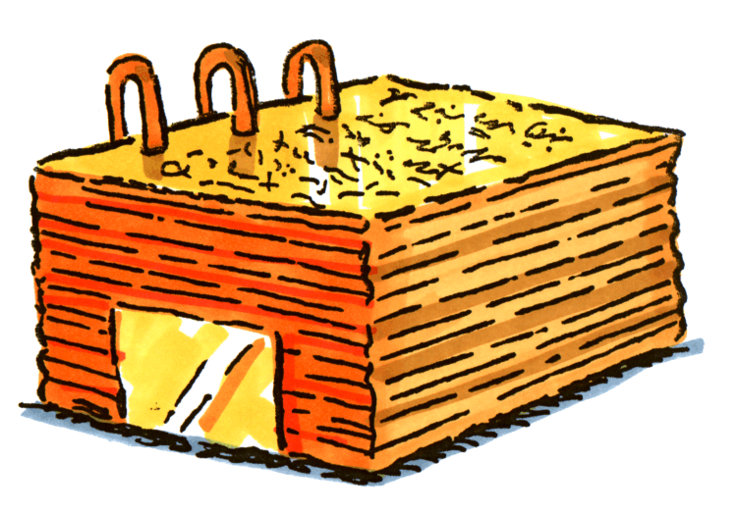
The Challenge

“The Book of Mormon Will Change Your Life”
-Ezra Taft Benson

President Benson has said, “May I admonish you to participate in a program of daily reading and pondering of the scriptures… The Book of Mormon will change your life. It will fortify you against the evils of our day. It will bring a spirituality into your life that no other book will. It will be the most important book you will read in preparation for a mission and for life. (Ezra Taft Benson, Ensign, May 1986, p. 43).

This is your chance to do something profoundly great this year. Let’s prove the statement by Ezra Taft Benson, “The Book of Mormon will change your life.”

To do this all you need to do is:
- Try the best you can to study daily from The Book of Mormon for at least 10 minutes on your own each day.
- Try your best to get all you can out of studying the Book of Mormon in class this year.

Throughout the year we will learn how to not just read from the scriptures but how to study and feast in the scriptures.

Throughout the year, we will look at what difference the challenge is making.

-----------------------------------------------------------
I hereby take the challenge to discover if the Book of Mormon will really change my life by trying my best to study 10 minutes daily and praying before reading in the Book of Mormon. I will also try to get all I can from studying the Book of Mormon in class this year.

Signed ________________________________

The Challenge

“The Book of Mormon Will Change Your Life”
-Ezra Taft Benson

President Benson has said, “May I admonish you to participate in a program of daily reading and pondering of the scriptures… The Book of Mormon will change your life. It will fortify you against the evils of our day. It will bring a spirituality into your life that no other book will. It will be the most important book you will read in preparation for a mission and for life. (Ezra Taft Benson, Ensign, May 1986, p. 43).

This is your chance to do something profoundly great this year. Let’s prove the statement by Ezra Taft Benson, “The Book of Mormon will change your life.”

To do this all you need to do is:
- Try the best you can to study daily from The Book of Mormon for at least 10 minutes on your own each day.
- Try your best to get all you can out of studying the Book of Mormon in class this year.

Throughout the year we will learn how to not just read from the scriptures but how to study and feast in the scriptures.

Throughout the year, we will look at what difference the challenge is making.

-----------------------------------------------------------
I hereby take the challenge to discover if the Book of Mormon will really change my life by trying my best to study 10 minutes daily and praying before reading in the Book of Mormon. I will also try to get all I can from studying the Book of Mormon in class this year.

Signed ________________________________

The Challenge

“The Book of Mormon Will Change Your Life”
-Ezra Taft Benson

President Benson has said, “May I admonish you to participate in a program of daily reading and pondering of the scriptures… The Book of Mormon will change your life. It will fortify you against the evils of our day. It will bring a spirituality into your life that no other book will. It will be the most important book you will read in preparation for a mission and for life. (Ezra Taft Benson, Ensign, May 1986, p. 43).

This is your chance to do something profoundly great this year. Let’s prove the statement by Ezra Taft Benson, “The Book of Mormon will change your life.”

To do this all you need to do is:
- Try the best you can to study daily from The Book of Mormon for at least 10 minutes on your own each day.
- Try your best to get all you can out of studying the Book of Mormon in class this year.

Throughout the year we will learn how to not just read from the scriptures but how to study and feast in the scriptures.

Throughout the year, we will look at what difference the challenge is making.

-----------------------------------------------------------
I hereby take the challenge to discover if the Book of Mormon will really change my life by trying my best to study 10 minutes daily and praying before reading in the Book of Mormon. I will also try to get all I can from studying the Book of Mormon in class this year.

Signed ________________________________
Great Quotes
Joseph Smith said, “I told the brethren that the Book of Mormon was the most correct of any book on earth, and the keystone of our religion, and a man would get nearer to God by abiding by its precepts, than by any other book” (History of the Church, 4:461).

President Benson has said, “May I admonish you to participate in a program of daily reading and pondering of the scriptures. … Young men [and women], the Book of Mormon will change your life. It will fortify you against the evils of our day. It will bring a spirituality into your life that no other book will. It will be the most important book you will read in preparation for a mission and for life. A young man [or woman] who knows and loves the Book of Mormon, who has read it several times, who has an abiding testimony of its truthfulness, and who applies its teachings will be able to stand against the wiles of the devil and will be a mighty tool in the hands of the Lord.” (Ezra Taft Benson, Ensign, May 1986, p. 43).

Later that year President Benson said, “There is a power in the book which will begin to flow into your lives the moment you begin a serious study of the book. You will find greater power to resist temptation. You will find the power to avoid deception. You will find the power to stay on the strait and narrow path. The scriptures are called “the words of life” (D&C 84:85), and nowhere is that more true than it is of the Book of Mormon. When you begin to hunger and thirst after those words, you will find life in greater and greater abundance.” (Ezra Taft Benson, Ensign, November 1986)

"No member of this Church can stand approved in the presence of God who has not seriously and carefully read the Book of Mormon..." (Joseph Fielding Smith, Conference Report, October 1961)

Great Quotes
Joseph Smith said, “I told the brethren that the Book of Mormon was the most correct of any book on earth, and the keystone of our religion, and a man would get nearer to God by abiding by its precepts, than by any other book” (History of the Church, 4:461).

President Benson has said, “May I admonish you to participate in a program of daily reading and pondering of the scriptures. … Young men [and women], the Book of Mormon will change your life. It will fortify you against the evils of our day. It will bring a spirituality into your life that no other book will. It will be the most important book you will read in preparation for a mission and for life. A young man [or woman] who knows and loves the Book of Mormon, who has read it several times, who has an abiding testimony of its truthfulness, and who applies its teachings will be able to stand against the wiles of the devil and will be a mighty tool in the hands of the Lord.” (Ezra Taft Benson, Ensign, May 1986, p. 43).

Later that year President Benson said, “There is a power in the book which will begin to flow into your lives the moment you begin a serious study of the book. You will find greater power to resist temptation. You will find the power to avoid deception. You will find the power to stay on the strait and narrow path. The scriptures are called “the words of life” (D&C 84:85), and nowhere is that more true than it is of the Book of Mormon. When you begin to hunger and thirst after those words, you will find life in greater and greater abundance.” (Ezra Taft Benson, Ensign, November 1986)

"No member of this Church can stand approved in the presence of God who has not seriously and carefully read the Book of Mormon..." (Joseph Fielding Smith, Conference Report, October 1961)

Great Quotes
Joseph Smith said, “I told the brethren that the Book of Mormon was the most correct of any book on earth, and the keystone of our religion, and a man would get nearer to God by abiding by its precepts, than by any other book” (History of the Church, 4:461).

President Benson has said, “May I admonish you to participate in a program of daily reading and pondering of the scriptures. … Young men [and women], the Book of Mormon will change your life. It will fortify you against the evils of our day. It will bring a spirituality into your life that no other book will. It will be the most important book you will read in preparation for a mission and for life. A young man [or woman] who knows and loves the Book of Mormon, who has read it several times, who has an abiding testimony of its truthfulness, and who applies its teachings will be able to stand against the wiles of the devil and will be a mighty tool in the hands of the Lord.” (Ezra Taft Benson, Ensign, May 1986, p. 43).

Later that year President Benson said, “There is a power in the book which will begin to flow into your lives the moment you begin a serious study of the book. You will find greater power to resist temptation. You will find the power to avoid deception. You will find the power to stay on the strait and narrow path. The scriptures are called “the words of life” (D&C 84:85), and nowhere is that more true than it is of the Book of Mormon. When you begin to hunger and thirst after those words, you will find life in greater and greater abundance.” (Ezra Taft Benson, Ensign, November 1986)

"No member of this Church can stand approved in the presence of God who has not seriously and carefully read the Book of Mormon..." (Joseph Fielding Smith, Conference Report, October 1961)

